**Module 5) HTML5**

**1)What are the new tags added in HTML5?**

* <article>
* <aside>
* <details>
* <figcaption>
* <figure>
* <footer>
* <header>
* <main>
* <mark>
* <nav>
* <section>
* <summary>
* <time>

**2)How to embed audio and video in a webpage?**

* **Audio tag**

To embed audio in HTML, we use the<audio> tag. Before HTML5, audio cannot be added to web pages in the internet explorer era. To play audio, we used web plugins like flash. After the release of HTML5, it is possible. This tag supports chrome, firefox, safari, opera and edge in three audio formats- MP3, WAV, OGG. Only the Safari browser doesn’t support OGG audio format.

**Example:**

<!DOCTYPE html>

<html lang="en">

<head>

<meta charset="UTF-8">

<meta name="viewport" content="width=device-width, initial-scale=1.0">

<title>Document</title>

</head>

<body>

<h2>Click play button to play audio</h2>

<audio src="../Html5/sample/sample.mp3" controls></audio>

</body>

</html>

**Output:**

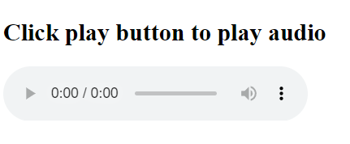

**Attributes of audio tag:**

Autoplay

Controls

Muted

Loop

Preload

Src

* **Video tag**

To embed video in HTML, we use the <video> tag. It contains one or more video sources at a time using <source> tag. It supports MP4, WebM, and Ogg in all modern browsers. Only ogg video format doesn’t support in safari browser.

**Example:**

<!DOCTYPE html>

<html lang="en">

<head>

<meta charset="UTF-8">

<meta name="viewport" content="width=device-width, initial-scale=1.0">

<title>Document</title>

</head>

<body>

<h1>Click play button to play video</h1>

<video src="../Html5/sample/samplevideo.mp4" controls></video>

</body>

</html>

**Output:**

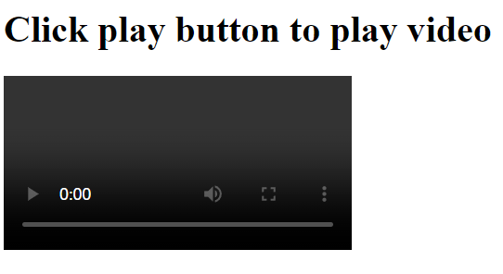

**Attributes of video tag:**

Autoplay

Controls

Muted

Loop

Preload

Src

Height

Width

Poster

**3)Semantic element in HTML5?**

* <article>
* <aside>
* <details>
* <figcaption>
* <figure>
* <footer>
* <header>
* <main>
* <mark>
* <nav>
* <section>
* <summary>
* <time>

**4)Canvas and SVG tags**

**Canvas**

The HTML element is used to draw graphics on the fly, via scripting(usually javascript). The element is only a container for graphics. You must use a script to actually draw the graphics. Canvas has several methods for drawing paths, boxes, circles, text, and adding images.

**SVG**

Scalable vector graphics is an XML-based image format used to define two-dimensional vector-based graphics for the web. Unlike raster images (Ex. jpg,gif,png etc) , a vector image can be scaled up or down to any extent without losing the image quality. An SVG image is drawn out using a series of statements that follow the XML schema that means SVG images can be created and edited with any text editor, such as notepad. There are several other advantages of using Svg over image formats like JPEG, GIF, PNG, etc.